**ER-Assistant User Guide**

ER-Assistant is a free entity-relationship diagramming tool that we will use to draw ERDs in this course. Unlike Visio, ER-Assistant is a small program designed to do just one thing – draw ERDs. ER-Assistant does NOT currently have a Mac version.

Free download: <http://highered.mcgraw-hill.com/sites/0072942207/student_view0/e_r_assistant.html>

***How to use ER Assistant?***

ER-Assistant is a simple tool and does not require training. But if you need a tutorial, the following YouTube video may be helpful.

<https://www.youtube.com/watch?v=a6UCXWJZ2GE>

***How to save the diagrams created in ER-Assistant?***

1. Save the diagram directly in ER-Assistant (with a “.erd” extension name)
2. Copy the diagram as an image and paste it in a Word document. Click Edit 🡪 Copy Diagram. The diagram won’t be editable in Word, but it allows multiple diagrams to be saved in one document.

***How to create supertype-subtype entities in ER-Assistant?***

To create a supertype entity STUDENT, you just need to check the Supertype box:

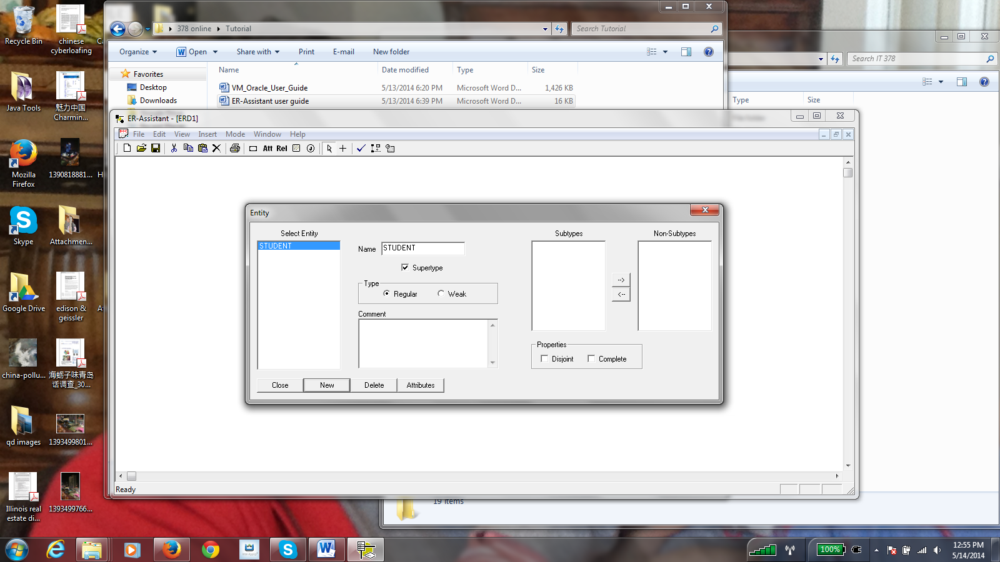

You then create two other entities, GRAD_STU and UNDERGRAD_STU, which will initially show up in the Non-Subtype column:

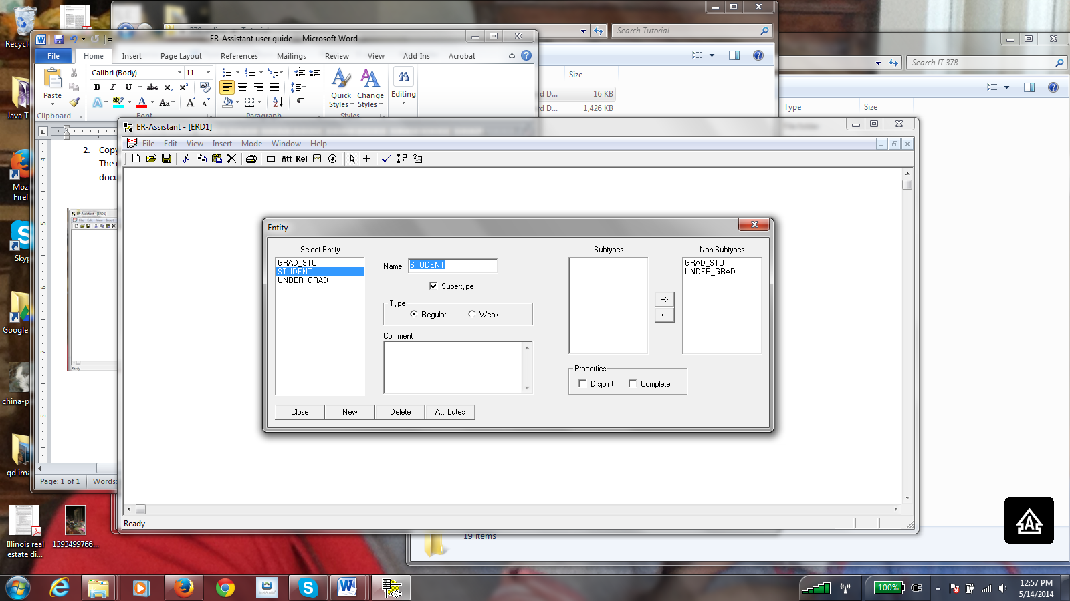

Move them over into the Subtype column (using the arrow):

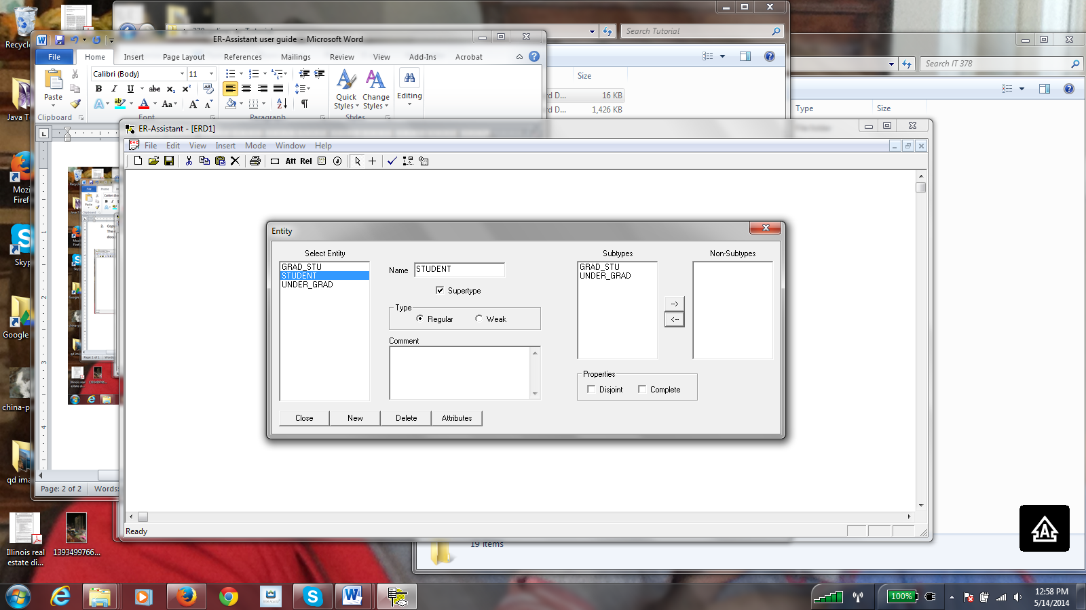

Then you specify the Disjoint/Completeness constraints by checking one box, both boxes, or neither box, depending on the situation. Both constraints apply in the example below:

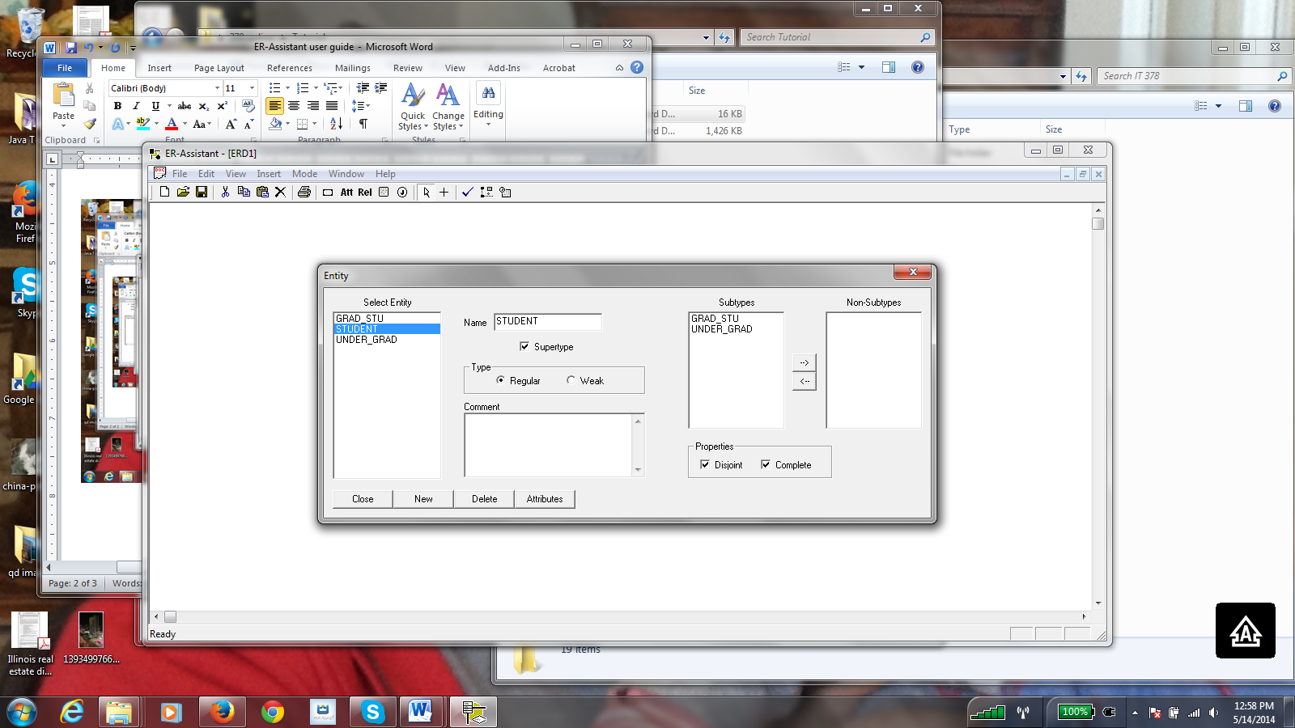

Click Close. You will have the supertype-subtype diagram below:

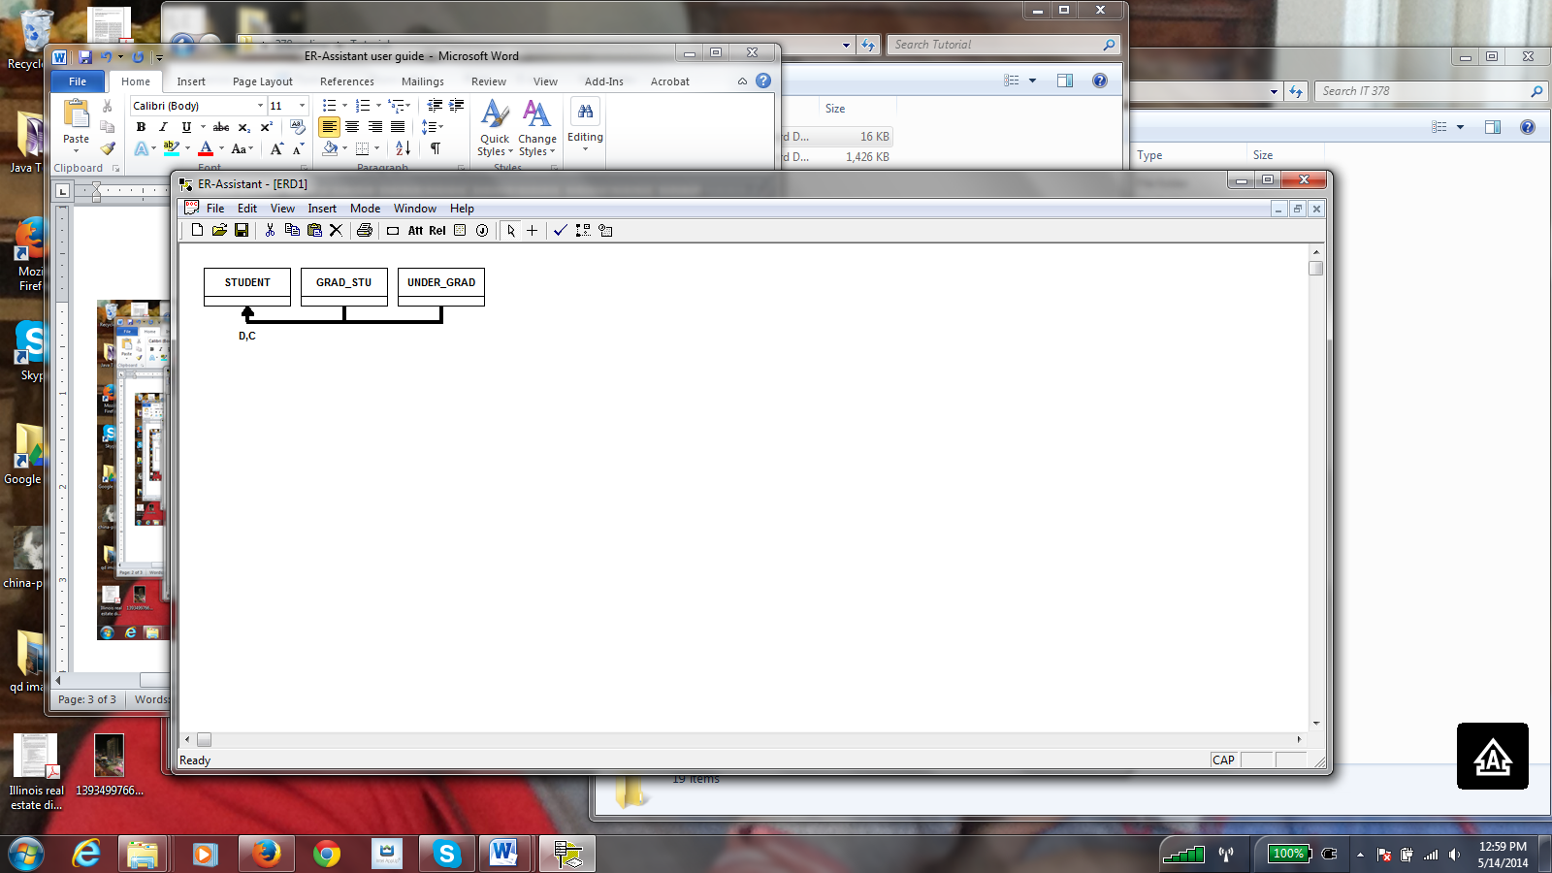

Don’t forget to move your entity boxes around to make the ERD more presentable



**Depending on which constraint boxes you have checked, your ERD could have only C, only D, both C and D, or neither C nor D.**

Note that ER-Assistant does not have a way to show subtype discriminators.